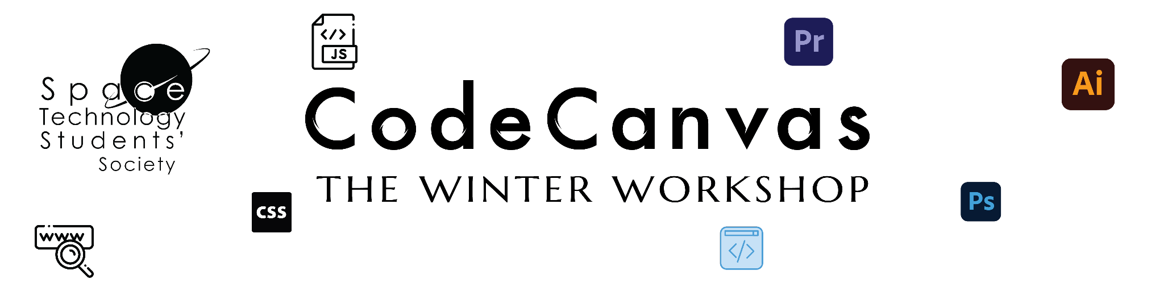

**Week 4**

**Video Editing in Design**

**29th December 2023**

**Week 4 Insights:** [Week 4 Mail CodeCanvas Design](https://docs.google.com/document/d/1fbKpDHE1HbEW_1LvqTEnBac757Z9QSPnrAhqr3oUbEY/edit)

**Week 4 Lessons:** [Week 4 - Premier Pro](https://docs.google.com/document/d/1tE1yh4omWp8XmGL4uQPW2yNOksPMEvscjiRZAnmrv2g/edit#heading=h.6gm2jla97m0z)

**Week 4 Submission Details:** [Week 4 Submission Mail Design](https://docs.google.com/document/d/1sBg5SdGqFlHpC-eBSM9oLRG4WYBX1kTpJum9EREtA8I/edit)

